Lab Database 풀어보기

2016110452 화학과 주현이

1.

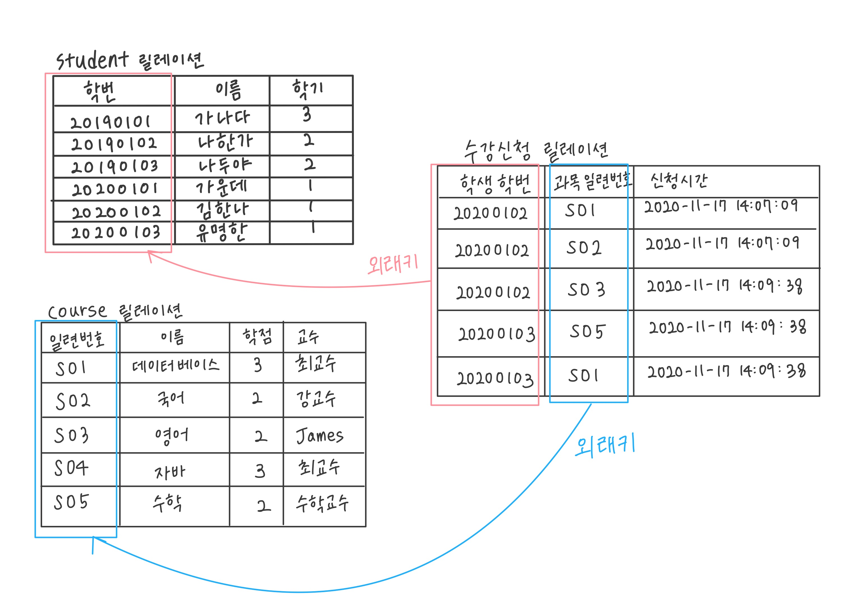

2.

create database dgu;

3.

create table student (id char(8), name varchar(20), semester int, primary key(id));

create table course (id char(8), name varchar(40), unit int, professor varchar(20), primary key(id));

create table register (st_id char(8), co_id char(8), regtime datetime);

4.

insert into student values ('20190101', '가나다', 3), ('20190102', '나한가', 2), ('20190103', '나두야', 2), ('20200101', '가운데', 1), ('20200102', '김한나', 1), ('20200103', '유명한', 1);

5.

insert into course values ('S01', '데이터베이스', 3, '최교수'), -> ('S02', '국어', 2, '강교수'), ('S03', '영어', 2, 'James'), ('S04', '자바', 3, '최교수'), 'S05', '수학', 2, '수학교수');

6.

insert into register (select st.id, co.id, now() from student st, course co where st.name = '김한나' and co.name = '데이터베이스');

8.

insert into register (select st.id, co.id, now() from student st, course co where st.name = '김한나' and (co.name = '국어' or co.name='영어'));

10.

insert into register (select st.id, co.id, now() from student st, course co where st.name = '가나다' and (co.name = '국어' or co.name='수학'));

insert into register (select st.id, co.id, now() from student st, course co where st.name = '나두야' and (co.name = '국어' or co.name='수학'or co.name='자바'));

11.

select c.name as 교과목, c.unit as 학점, c.professor as 교수 from student s, register r, course c

where s.name = '김한나' and s.id = r.st_id and c.id = r.co_id order by c.name;

12.

select s.name as 이름, count(*) as 과목수, sum(c.unit) as 학점 from student s, register r, course c where s.id = r.st_id and c.id = r.co_id group by s.name;

13.

delete from register where st_id = (select id from student where name = '김한나') and co_id = (select id from course where name = '국어');

14.

update student set semester = semester+1 where id in (select st_id from register);

15.

select co_id, count(st_id) as 학생수 from register group by co_id;

했을 때 5명 미만인 과목은 S01, S03, S04이므로 course에서 삭제한다.

delete from course where co_id='S01';

delete from course where co_id='S03';

delete from course where co_id='S04';